***1.Bug Title:* User Unable to Create Profile with a valid phone number less than 10 digits**

***2.Severity :***

* **High**

***3.Reproducibility***

* **Always**

***4.Bug Type/Category***

* **Functionality**

***5.Steps to Reproduce***

* **Go to** [**https://qa-assessment.pages.dev/**](https://qa-assessment.pages.dev/)
* **Enter a 9 digit phone number in the phone number field**
* **Enter valid information in the remaining input fields**
* **Click on the “submit” button**

***6.Expected Results***

* **User profile is supposed to be successfully created when on submit button is clicked if the user enters digits less than or equal to 10**

***7.Actual Results***

* **Error message is shown at the phone number field after the “submit “ button is clicked if user does not enter a phone number exactly 10 digits**

***8.Screenshot/screenrecord link of bug***

**-screenShot**

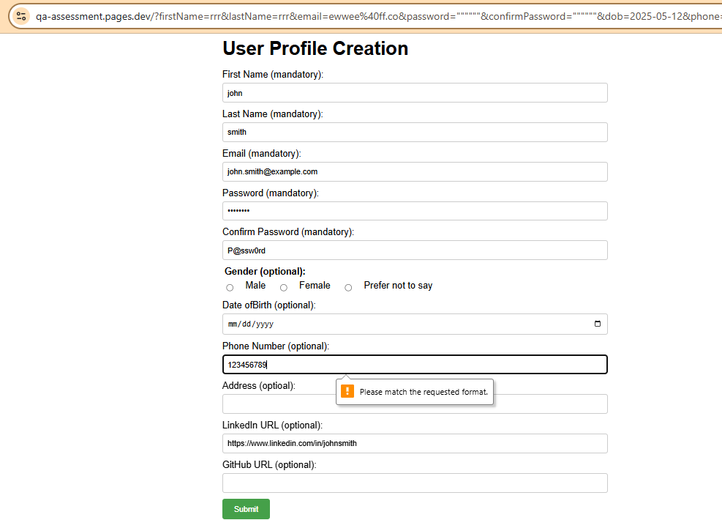

***9.Device Information***

**- Occurs on all Devices**

**-Connection type and speed: Mobile data / 17Mbps**